Experiment No:-
Name: Bhagyashree Rajgonda Patil Roll No: 27
Class: MCA SY Semester: 3rd
Subject: Mobile Application Development Batch: M2

Q) Designing User Interfaces Using Different Android Layout Managers: Linear, Relative,Constraint,Frame,and Table Layout.

- Linear Layout
• Activity_main.xml

<?xml version="1.0" encoding="utf-8"?>
<LinearLayout xmlns:android="http://schemas.android.com/apk/res/android" xmlns:app="http://schemas.android.com/apk/res-auto" android:layout_width="match_parent" android:layout_height="match_parent"
android:orientation="vertical">

<!-- Toolbar -->
<androidx.appcompat.widget.Toolbar
android:id="@+id/toolbar"
android:layout_width="match_parent" android:layout_height="?attr/actionBarSize" android:background="?attr/colorPrimary" android:theme="@style/ThemeOverlay.AppCompat.Dark.ActionBar" android:title="Compose Email" android:titleTextColor="@android:color/white" app:popupTheme="@style/ThemeOverlay.AppCompat.Light" />

<!-- Email Form Layout --> <LinearLayout android:layout_width="match_parent" android:layout_height="match_parent" android:orientation="vertical" android:paddingLeft="20dp" android:paddingRight="20dp" android:paddingTop="10dp" android:layout_weight="1">

<EditText
android:id="@+id/txtTo" android:layout_width="match_parent" android:layout_height="wrap_content" android:hint="To" />

<EditText android:id="@+id/txtSub" android:layout_width="match_parent" android:layout_height="wrap_content" android:hint="Subject" />

<EditText android:id="@+id/txtMsg" android:layout_width="match_parent" android:layout_height="0dp" android:layout_weight="1" android:gravity="top" android:hint="Message" android:inputType="textMultiLine" android:overScrollMode="always" android:scrollbars="vertical" />

<Button android:layout_width="100dp" android:layout_height="wrap_content" android:layout_gravity="end" android:text="Send" />
</LinearLayout>
</LinearLayout>

- Mainactivity.java
package com.examples.linear_layout;
import android.os.Bundle;
import androidx.appcompat.app.AppCompatActivity;
import androidx.appcompat.widget.Toolbar;

public class MainActivity extends AppCompatActivity {
@Override protected void onCreate(Bundle savedInstanceState) { super.onCreate(savedInstanceState); setContentView(R.layout.activity_main);
Toolbar toolbar = findViewById(R.id.toolbar); setSupportActionBar(toolbar);
}
}

- Output:
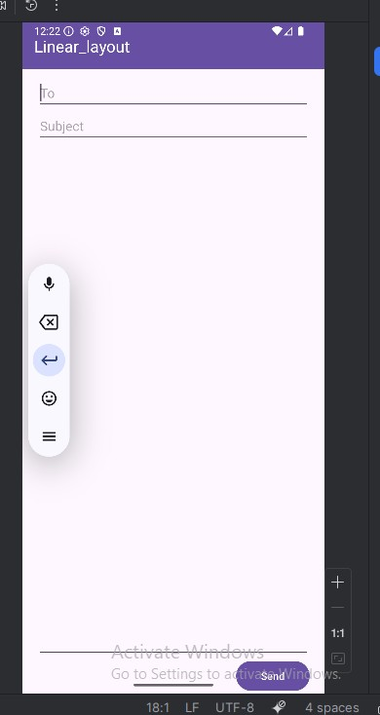

- Relative Layout

- Activitymain.xml

<?xml version="1.0" encoding="utf-8"?>
<RelativeLayout xmlns:android="http://schemas.android.com/apk/res/android" android:layout_width="match_parent" android:layout_height="match_parent" android:paddingLeft="10dp"
android:paddingRight="10dp">
<Button
android:id="@+id/btn1" android:layout_width="wrap_content" android:layout_height="wrap_content" android:layout_alignParentLeft="true" android:text="Button1" />
<Button
android:id="@+id/btn2" android:layout_width="wrap_content" android:layout_height="wrap_content" android:layout_alignParentRight="true" android:layout_centerVertical="true" android:text="Button2" />
<Button
android:id="@+id/btn3" android:layout_width="wrap_content" android:layout_height="wrap_content" android:layout_alignParentLeft="true" android:layout_centerVertical="true" android:text="Button3" />

<Button
android:id="@+id/btn4" android:layout_width="match_parent" android:layout_height="wrap_content" android:layout_alignParentBottom="true" android:text="Button4" />
<Button
android:id="@+id/btn5" android:layout_width="wrap_content" android:layout_height="wrap_content" android:layout_alignBottom="@+id/btn2" android:layout_centerHorizontal="true" android:text="Button5" />
<Button
android:id="@+id/btn6" android:layout_width="wrap_content" android:layout_height="wrap_content" android:layout_above="@+id/btn4" android:layout_centerHorizontal="true" android:text="Button6" />
<Button
android:id="@+id/btn7" android:layout_width="wrap_content" android:layout_height="wrap_content" android:layout_toEndOf="@+id/btn1" android:layout_toRightOf="@+id/btn1" android:layout_alignParentRight="true" android:text="Button7" />
</RelativeLayout>

- MainActivity.java

Package com.examples.relativelayout
import android.os.Bundle;
import androidx.activity.EdgeToEdge;
import androidx.appcompat.app.AppCompatActivity; import androidx.core.graphics.Insets;
import androidx.core.view.ViewCompat;
import androidx.core.view.WindowInsetsCompat;
public class MainActivity extends AppCompatActivity {
@Override protected void onCreate(Bundle savedInstanceState) { super.onCreate(savedInstanceState); EdgeToEdge.enable(this); setContentView(R.layout.activity_main);
}
}

Output:
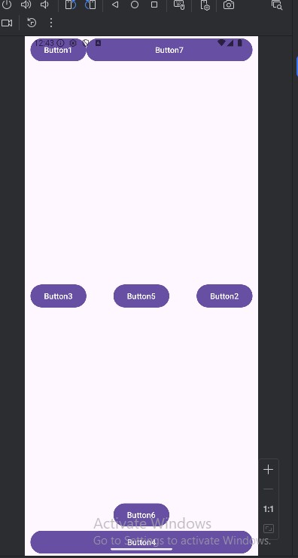

3) Table Layout

Activity_main.xml

<?xml version="1.0" encoding="utf-8"?>
<TableLayout xmlns:android="http://schemas.android.com/apk/res/android" android:layout_width="match_parent" android:layout_height="match_parent"
android:layout_marginTop="100dp"
android:paddingLeft="10dp"
android:paddingRight="10dp" >
<TableRow android:background="#0079D6"
android:padding="5dp">
<TextView android:layout_width="wrap_content" android:layout_height="wrap_content" android:layout_weight="1" android:text="UserId" />
<TextView android:layout_width="wrap_content" android:layout_height="wrap_content" android:layout_weight="1" android:text="User Name" />
<TextView
android:layout_width="wrap_content" android:layout_height="wrap_content" android:layout_weight="1" android:text="Location" />
</TableRow>
<TableRow android:background="#DAE8FC"
android:padding="5dp">
<TextView android:layout_width="wrap_content" android:layout_height="wrap_content" android:layout_weight="1" android:text="1" />
<TextView android:layout_width="wrap_content" android:layout_height="wrap_content" android:layout_weight="1" android:text="Bhagyashree Patil" />
<TextView android:layout_width="wrap_content" android:layout_height="wrap_content" android:layout_weight="1" android:text="Pune" />
</TableRow>
<TableRow android:background="#DAE8FC"
android:padding="5dp">
<TextView android:layout_width="wrap_content" android:layout_height="wrap_content" android:layout_weight="1" android:text="2" />
<TextView android:layout_width="wrap_content" android:layout_height="wrap_content" android:layout_weight="1" android:text="Shravani Desai" />
<TextView android:layout_width="wrap_content" android:layout_height="wrap_content" android:layout_weight="1" android:text="Mumbai" />
</TableRow>
<TableRow android:background="#DAE8FC"
android:padding="5dp">
<TextView android:layout_width="wrap_content" android:layout_height="wrap_content" android:layout_weight="1" android:text="3" /> <TextView android:layout_width="wrap_content" android:layout_height="wrap_content" android:layout_weight="1" android:text="Sanika Patil" />
<TextView android:layout_width="wrap_content" android:layout_height="wrap_content" android:layout_weight="1" android:text="Pune" />
</TableRow> </TableLayout>

- MainActivity.java

Package com.examples.tablelayout;
import android.os.Bundle;
import androidx.activity.EdgeToEdge;
importandroidx.appcompat.app.AppCompatActivity; import androidx.core.graphics.Insets;
import androidx.core.view.ViewCompat;
import androidx.core.view.WindowInsetsCompat;

public class MainActivity extends AppCompatActivity {
@Override protected void onCreate(Bundle savedInstanceState) { super.onCreate(savedInstanceState); EdgeToEdge.enable(this); setContentView(R.layout.activity_main);
}
}

- Output

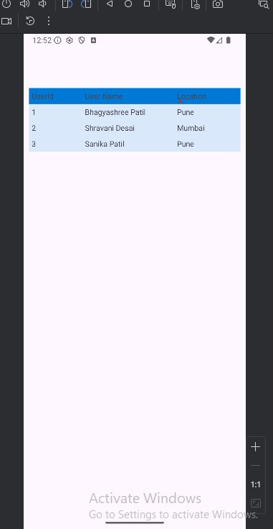

- Frame layout

- Activity_main.xml

<?xml version="1.0" encoding="utf-8"?>
<FrameLayout xmlns:android="http://schemas.android.com/apk/res/android" android:layout_width="match_parent" android:layout_height="match_parent">

<!-- Centered Image --> <ImageView android:id="@+id/imgvw1" android:layout_width="wrap_content" android:layout_height="wrap_content" android:layout_gravity="center" android:scaleType="centerCrop" android:src="@drawable/grand_palace" />

<!-- Top Text -->
<TextView android:id="@+id/txtvw1" android:layout_width="match_parent" android:layout_height="wrap_content" android:layout_marginTop="40dp" android:background="#4C374A" android:padding="10dp" android:text="Grand Palace, Bangkok" android:textColor="#FFFFFF" android:textSize="20sp" />

<!-- Bottom-Right Date Text --> <TextView android:id="@+id/txtvw2" android:layout_width="wrap_content" android:layout_height="wrap_content" android:layout_gravity="bottom|end" android:layout_margin="16dp" android:background="#AA000000" android:padding="10dp" android:text="21/Aug/2017" android:textColor="#FFFFFF" android:textSize="18sp" />

</FrameLayout>

- Main_Activity.java

package com.examples.framelayout;
import android.os.Bundle;
import androidx.activity.EdgeToEdge;
import androidx.appcompat.app.AppCompatActivity;
import androidx.core.graphics.Insets;
import androidx.core.view.ViewCompat;
import androidx.core.view.WindowInsetsCompat;

public class MainActivity extends AppCompatActivity {

@Override protected void onCreate(Bundle savedInstanceState) { super.onCreate(savedInstanceState); EdgeToEdge.enable(this); setContentView(R.layout.activity_main);

}
}

Output:
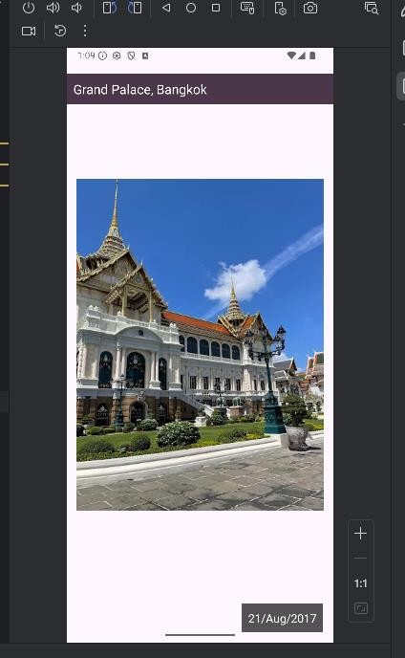

5) Constraint layout

Activity_main.xml

<?xml version="1.0" encoding="utf-8"?> <androidx.constraintlayout.widget.ConstraintLayout xmlns:android="http://schemas.android.com/apk/res/android" xmlns:app="http://schemas.android.com/apk/res-auto" android:layout_width="match_parent"
android:layout_height="match_parent">

<!-- Centered Image -->
<ImageView
android:id="@+id/imgvw1" android:layout_width="200dp" android:layout_height="200dp" android:scaleType="centerCrop" android:src="@drawable/grand_palace" app:layout_constraintTop_toTopOf="parent" app:layout_constraintBottom_toBottomOf="parent" app:layout_constraintStart_toStartOf="parent" app:layout_constraintEnd_toEndOf="parent"/>

<!-- Top Title Text --> <TextView android:id="@+id/txtvw1" android:layout_width="0dp" android:layout_height="wrap_content" android:background="#4C374A" android:padding="10dp" android:text="Grand Palace, Bangkok" android:textColor="#FFFFFF" android:textSize="20sp" app:layout_constraintTop_toTopOf="parent" app:layout_constraintStart_toStartOf="parent" app:layout_constraintEnd_toEndOf="parent" app:layout_constraintHorizontal_bias="0"/>

<!-- Bottom-Right Date Text -->
<TextView
android:id="@+id/txtvw2" android:layout_width="wrap_content" android:layout_height="wrap_content" android:background="#AA000000" android:padding="10dp" android:text="21/Aug/2017" android:textColor="#FFFFFF" android:textSize="18sp" android:layout_marginBottom="16dp" android:layout_marginEnd="16dp" app:layout_constraintBottom_toBottomOf="parent" app:layout_constraintEnd_toEndOf="parent"/> </androidx.constraintlayout.widget.ConstraintLayout>

MainActivity.java

package com.examples.constraintlayout;
import android.os.Bundle;
import androidx.activity.EdgeToEdge;
import androidx.appcompat.app.AppCompatActivity; import androidx.core.graphics.Insets;
import androidx.core.view.ViewCompat;
import androidx.core.view.WindowInsetsCompat;

public class MainActivity extends AppCompatActivity {
@Override protected void onCreate(Bundle savedInstanceState) { super.onCreate(savedInstanceState); EdgeToEdge.enable(this); setContentView(R.layout.activity_main);
}
}

Output:
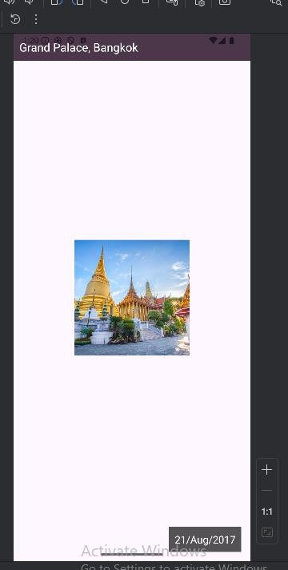

Cognitive  (04) | Psychomotor  Skill (04) | Affective Domain (02) | Total (10) | Sign

